**CI/CD through Push Over SSH**

1. On Jenkin server Add user jenkins-deploy

adduser jenkins-deploy

2. Change password for deploy user

passwd jenkins-deploy

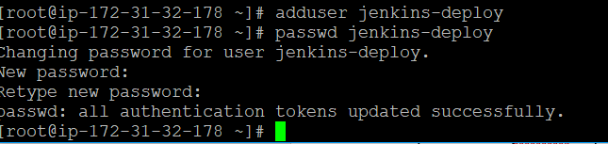

3. add the same user on tomcat server:

adduser jenkins-deploy

passwd jenkins-deploy

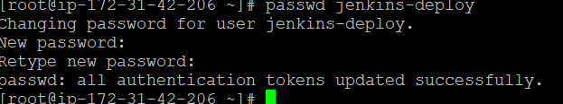

4. edit sodoers on tomcat and jenkins server both

sudo visudo

Add following content

jenkins-deploy ALL=(ALL) NOPASSWD: ALL



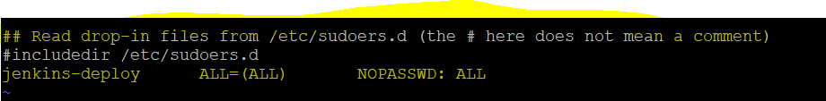

5. On tomcat Instance, allow remote root login by uncommenting PermitRootLogin

vi /etc/ssh/sshd_config

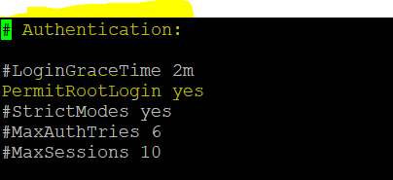

And restart service

service sshd restart

6. on Jenkins server --> switch to user jenkins-deploy

sudo su - jenkins-deploy



7. create a key for user jenkins-deploy

ssh-keygen -m PEM -t rsa -b 4096

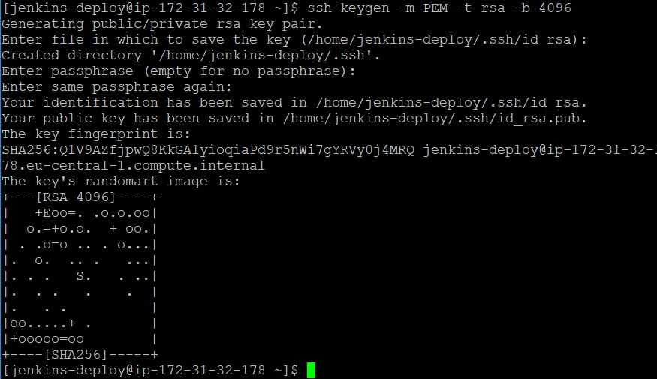

8. Now copy public ssh of jenkins-deploy user to tomcat

Syntax: ssh-copy-id -i PUBLIC_KEY_PATH USER jenkins-deploy@tomcat private ip

ssh-copy-id -i /home/jenkins-deploy/.ssh/id_rsa.pub [jenkins-deploy@172.31.42.206](mailto:jenkins-deploy@172.31.42.206)

9. Add configuration for ssh in Manage jenkins, make sure you already install Publish over ssh plugin

Manage jenkins->Configure System

-Name: jenkins-deploy

hostname: 172.31.47.250

username: jenkdeply

remote directory: /usr/share/tomcat/webapps

click on advance->use password authentication

add password for user

Test configuration

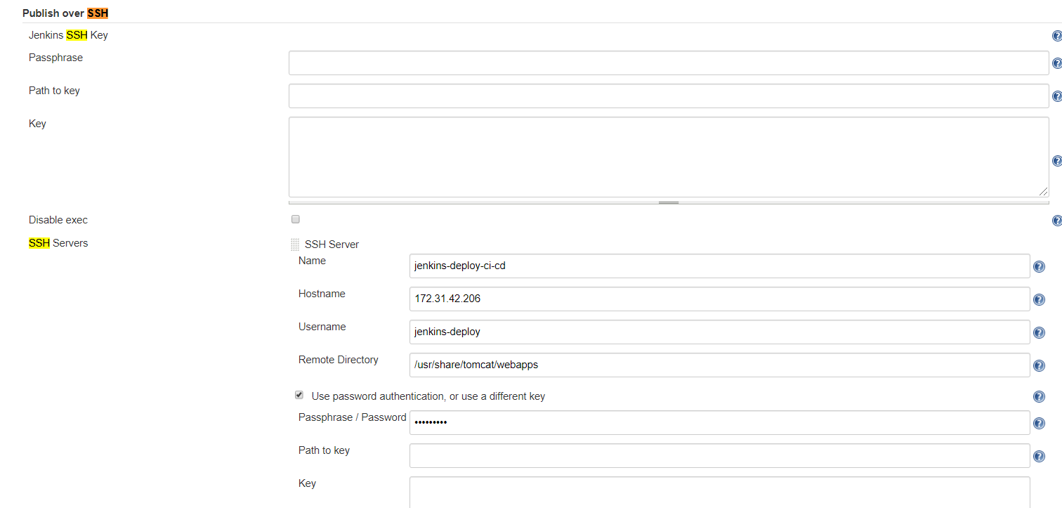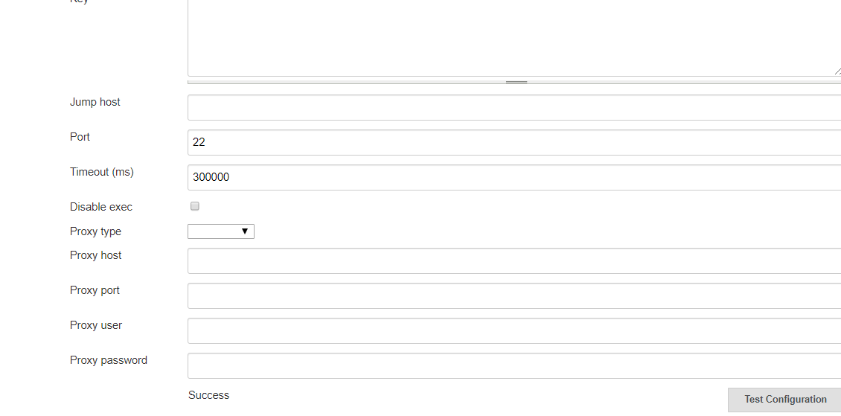

9. create CI and CD job.

In the CD job : post build action -> send build artifacts over ssh

